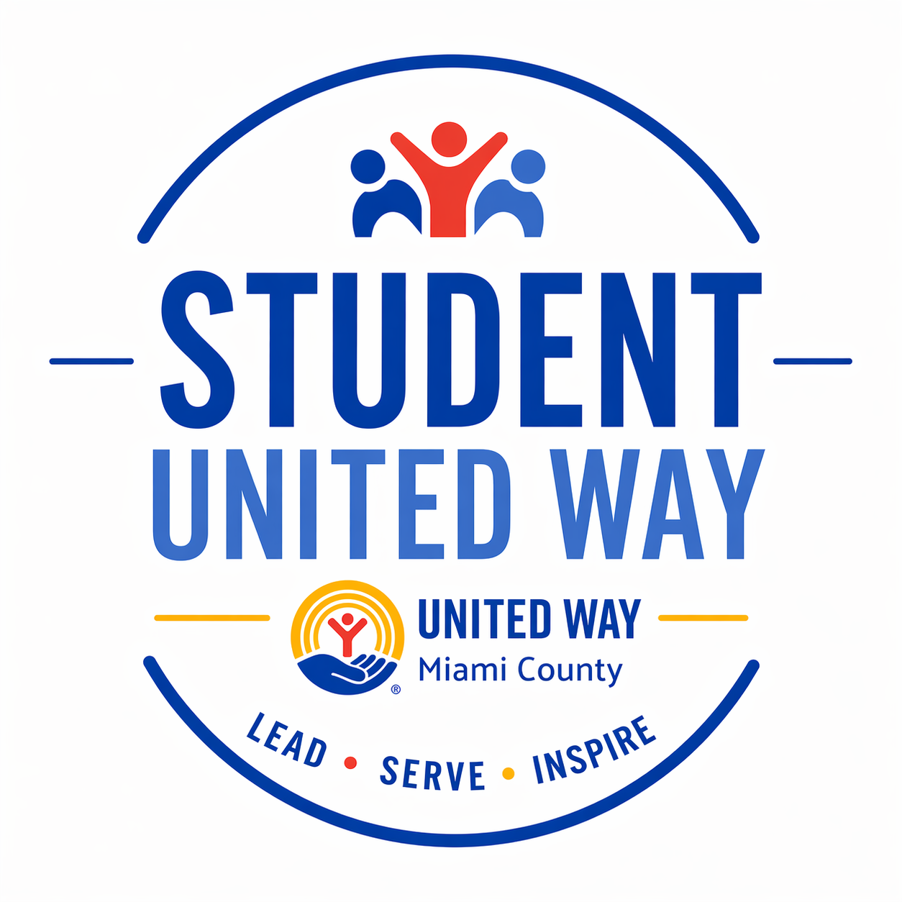
The Student United Way of Miami County is a leadership and service-based program that empowers high school students to make a difference in their community. Selected students will represent their school, participate in monthly site visits to local nonprofit agencies, and engage in meaningful service projects. The program builds leadership, awareness, and a lifelong commitment to giving back.

United Way of Miami County — Student United Way Application
Empowering Future Leaders. Inspiring Community Impact.

Student Information (Please write legibly)
Name: ___________________________________________
Grade (as of Fall 2026): ___________________________________________
High School: ___________________________________________
Home Address: ___________________________________________
Email Address: ___________________________________________
Phone Number: ___________________________________________

Parent/Guardian Information
Parent/Guardian Name(s): ___________________________________________
Phone Number: ___________________________________________
Email Address: ___________________________________________

Short Answer Questions
1. Why do you want to be part of the Student United Way?
______________________________________________________________
______________________________________________________________
2. What leadership experience or community involvement have you had?
______________________________________________________________
______________________________________________________________
3. What do you hope to gain from participating in this program?
______________________________________________________________
______________________________________________________________

Availability Commitment
Student United Way members are expected to attend monthly meetings, participate in site visits, and engage in community service.
Are you able to commit to one meeting or activity per month from September through May?
☐ Yes ☐ No
If no, please explain: ____________________________________________

Student & Parent/Guardian Consent
By signing below, I confirm that I understand the commitment involved in Student United Way and I agree to participate fully if selected.
Student Signature: ____________________________ Date: ___________
Parent/Guardian Signature: ____________________ Date: ___________

School Approval
To be considered, this form must be signed by your Superintendent or a designated representative.
I support this student's application to Student United Way and confirm they are in good standing at our school.
Superintendent Name: ______________________________
Signature: ____________________________ Date: ___________
School District: ______________________________

Submit Your Application To:
Sean Ford
Chief Executive Officer
United Way of Miami County
📧 sean@unitedwaymco.org

